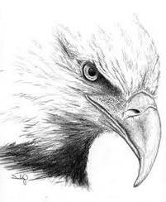
NEW MARTINSVILLE SCHOOL ATHLETIC PACKET 2023/2024

WVSSAC ruling states that NO student can practice
until the Athletic Sports Packet has been turned in and approved by the NMS Athletic Director.

Get physical – at your expense
Complete and sign ALL forms
Return completed athletic packet to the 7/8 office on the first day of school or give to your coach if the sport has started before school starts

NEW MARTINSVILLE SCHOOL ATHLETIC CODE OF CONDUCT

1. Athlete must attend ALL practice sessions, athletic contests, fund raising activities and pep rallies. If an athlete misses for any reason, a written note must be provided to the coach. If the athlete is also absent from school, one note will suffice. Any unexcused absences may result in suspension from practice and/or games. The coach should be notified in advance of medical/dental appointments. Non-school activities will be counted as unexcused absences.

2. When representing New Martinsville School, an athlete must:
▪ wear uniforms and shoes that are clean and neatly pressed.
▪ have their hair clean and in a style off the face.
▪ have a neat and well-groomed appearance, including moderately applied makeup for cheerleaders
▪ not use profane, vulgar, or crude language
▪ not wear jewelry
▪ conduct themselves in a manner worthy of themselves, their parents and the school while traveling, practicing or competing.

Any violation may result in suspension from practices and/or athletic contests.

3. Athlete must be prompt and on time to school, practice, athletic contest and bus trip. Chronic problems may result in suspensions from practice and/or athletic contest.

4. To participate in a practice/contest, an athlete must attend homeroom and all scheduled classes that day. Exceptions can made by the principal on an individual basis for absences due to a medical appointment or funeral with a written note from the professional.

5. Athlete must attend school the day after a practice/contest to earn the privilege to practice/participate in a contest.

6. Any athlete caught using tobacco products, vapes, drinking alcoholic beverages or using illegal drugs will be suspended from school and will not be permitted on school property while on suspension. Athlete may also be removed from the team.

7. All athletes must maintain a 2.0 grade point average (GPA) per semester to be eligible.

8. Any athlete acquiring 3 suspensions from practice or contest will be dismissed from the team.

9. Athletes are responsible for any equipment or uniforms issued from the school and will be financially responsible for anything that is lost or damaged beyond normal wear.

10. Athletes must ride the transportation arranged by the school to and from athletic contest unless excused by the coach. They may only ride with his/her parent or school board employee. A written authorization will also be required.

11. Athletes will be responsible for providing their own personal items such as shoes, socks, undergarments, and/or hair accessories.

NEW MARTINSVILLE SCHOOL FAN CODE OF CONDUCT

New Martinsville School, in association with the West Virginia Secondary School Activities Commission, promotes interscholastic events and sportsmanship. Behavior should be positive, respectful and encouraging of the athletes, coaches, officials and the game.
Fans are encouraged to:
- Cheer, sing, and support teams
- Be courteous
- Comply with requests from administration and/or facilities staff regarding school policies and emergency response procedures
- Exhibit good sportsmanship at all times

Any Behavior that is reckless, dangerous, disruptive, or illegal in nature may result in removal from event, law enforcement notification, suspensions of privilege, and/or fines. Failing to follow instructions of school personnel or law enforcement officers, will result in immediate removal from premises and may include suspensions of privilege, and/or fines.

Entering locker rooms of either team unless granted permission by coach or athletic director is not allowed.

Any athletic official, including but not limited to, contest officials, athletic director, principal, assistant principal, game site supervisors, anyone in an administrative role on the site, and law enforcement may uphold enforcement of an ejection. While the Fan Code of Conduct encompasses behavior expectations and consequences for both student and adult fans, further consequences to a student ejected from a contest due to violating the Student Code of Conduct may occur. Appeals must be received by the principal’s office no later than 10 business days after the effective date of the penalty.

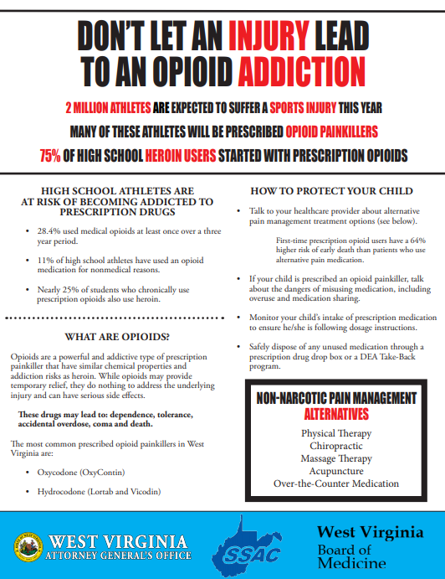
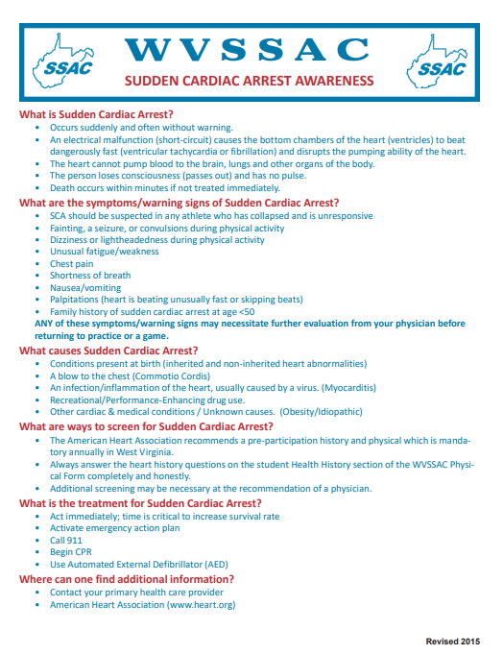

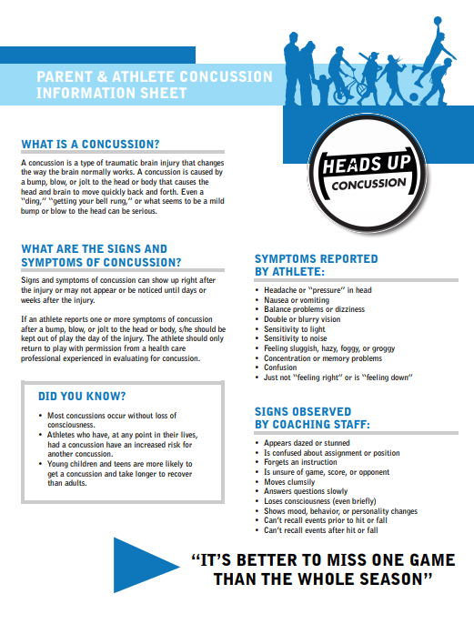
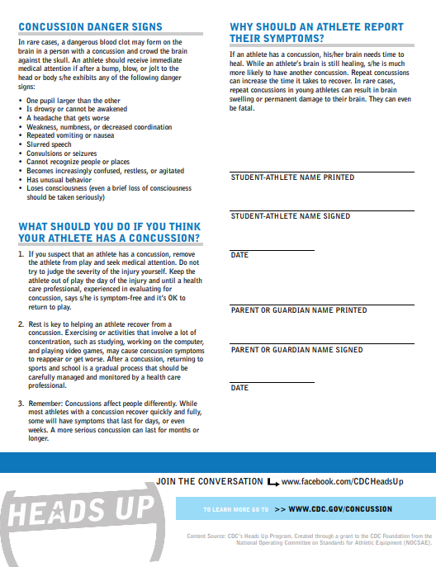

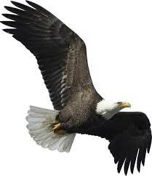
NEW MARTINSVILLE SCHOOL
BASIC HEALTH CARE COVERAGE AND EMERGENCY INFORMATION

Student Student Student
First Name ___________________________ Middle Initial _____ Last Name ___________________________

Circle: Male Female Circle Grade: 6 7 8

Date of Birth _____________ City of Birth _________________________ State of Birth _______

Street Address _________________________ City ________________________ Zip ______

Father’s Full Name_____________________________________________________________
Cell # _______________________ Work # __________________________
Landline # ___________________ Employer ________________________

Mother’s Full Mother’s Maiden
Name__________________________________________ Name________________________

Cell # _______________________ Work # __________________________
Landline # ___________________ Employer ________________________

Another person to contact
in an emergency ____________________________________

Relationship_______________________

Cell # _______________________ Work # __________________________
Landline # ___________________ Employer ________________________

Health Insurance Company ______________________________________________

Policy And/Or Group Numbers___________________________________________

Allergies______________________________________________________________

Health Problems_______________________________________________________

Family Physician _____________________ Preferred Other_____________________
ACKNOWLEDGEMENT

We the undersigned are the Parent(s) and/or Legal Guardians of _____________________________________,
a student at New Martinsville School. The student desires to participate in the following extracurricular activities during the 2023-2024 academic year. Check all that apply.

□ Football □ Volleyball □ Cheerleading □ Wrestling □ Basketball □ Track

We understand that there is a substantial risk of injury to the student while participating and that there is an enhanced possibility of injury to those who participate in contact sports. We have considered the risk of injury to the student and discussed the existence of those risks with the student who, nevertheless, desires to participate. We hereby consent to his/her participation in each of those activities identified above.

Considering the risk of injury to the student, we hereby understand the necessity for providing medical coverage. The following describes the insurance status of the student (Check one)

□ We have reviewed the terms and conditions of our medical coverage and are satisfied that in the event of injury there exists enough coverage to provide treatment and care to the student.

Name of Insurance Carrier: Policy Number:

□ The student has not medical coverage and any injury related medical expenses resulting from injury to the student will be borne by me/us.

In signing this document, it is acknowledged that we/I understand that the student may get hurt and that we/I have made an informed decision, in consultation with the student, to approve and consent to his/her participation. We further acknowledge that the Wetzel County Board of Education is not responsible for payment of medical expenses incurred as a result of any injury suffered by the student while participating in the previously identified extracurricular activities.

Secondly, we/I hereby give consent for my/our child to accompany any school team of which he/she is a member on its local and out-of-town trips.

Finally, we/I hereby give consent for my/our child to receive, through a medical doctor of the school’s choice, emergency medical care that may become necessary during such athletic activities or such travel.

√__________________________________________ _____________________
Parent/Guardian(s) Signature(s) Date

I, the undersigned student, have reviewed this Acknowledgement with my parent(s) and/or legal guardian(s) and fully understand that I might get hurt while participating in the previously identified extracurricular activities. I also understand that the Wetzel County Board of Education is not responsible for payment of any expenses that may be incurred for treatment of any injury I may suffer. I have considered the risk associated with participating in the above extracurricular activities and have nevertheless made an informed decision to participate.

√__________________________________________ ______________________
Student Athlete Signature Date

NEW MARTINSVILLE SCHOOL
ATHLETIC CODE OF CONDUCT

1. Athletes must attend ALL practice sessions, athletic contests, fund raising activities and pep rallies. If an athlete misses for any reason, a written note must be provided to the coach. If the athlete is also absent from school, one note will suffice. Any unexcused absences may result in suspension from practice and/or games. The coach should be notified in advance of medical/dental appointments. Non-school activities will be counted as unexcused absences.

2. When representing New Martinsville School, an athlete must:
▪ wear uniforms and shoes that are clean and neatly pressed.
▪ have their hair clean and in a style off the face.
▪ have a neat and well-groomed appearance, including moderately applied makeup for cheerleaders
▪ not use profane, vulgar, or crude language
▪ not wear jewelry
▪ conduct themselves in a manner worthy of themselves, their parents and the school while traveling, practicing or competing.

Any violation may result in suspension from practices and/or athletic contests.

3. Athletes should be prompt and on time for practice, athletic contests, bus trips and school. Chronic problems may result in suspensions from practice and/or athletic contests.

4. Athletes must be in school and participate in scheduled physical education classes in order to participate in practices and athletic contests that day. Exceptions can be made on an individual basis for things such as but not limited to, funerals, medical appointments, etc. Any athlete leaving school without permission will automatically be suspended from the next athletic contest.

*Special attention will be paid for school days after athletic contests concerning #3 and #4.

5. Any athlete using tobacco products, drinking alcoholic beverages, or using illegal drugs will be suspended. Athletes will also not be present where these activities are taking place.

6. All athletes must maintain a 2.0 grade point average (GPA) per semester to be eligible.

7. Any athlete acquiring 3 suspensions from practice or games will be dismissed from the team.

8. Athletes are responsible for any equipment or uniforms issued from the school and will be financially responsible for anything that is lost or damaged beyond normal wear.

9. Athletes must ride the transportation arranged by the school to and from athletic contest unless excused by the coach. They may only ride with his/her parent or school board employee. A written authorization will also be required.

10. Athletes will be responsible for providing their own personal items such as shoes, socks, undergarments, and/or hair accessories.

I agree as an athlete and a parent/guardian to abide by the New Martinsville School Athletic Code of Conduct.

√___________________________________ ____________
Parent/Guardian Signature Date
√___________________________________ ____________
Student Athlete Signature Date

WETZEL COUNTY SCHOOL CODE OF CONDUCT FOR STUDENTS
PARTICIPATING IN EXTRA AND/OR CO-CURRICULAR ACTIVITIES

For student participants in any extra and/or co-curricular activity to have the opportunity to reach their potential, they shall adhere to a set of minimum standards. The following set of standards is set by the Wetzel County Board of Education as minimum standards and may be supplemented by local school rules.

1. Behave in a manner that does not disrupt the activity, school, or location where the activity is being conducted.

2. Obey and show respect for all adult supervisors.

3. Attend the events of the activity, complete his/her assignments for the activity on time, and work to his/her full potential.

4. Refrain from aggressive or threatening behavior toward fellow students, teachers, or other supervisors.

5. Refrain from the possession or use of any weapon, illegal drug, alcohol, or tobacco products.

6. Refrain from all criminal activity.

7. Exhibit good sportsmanship, both in victory and in defeat.

8. Understand and observe the rules, regulations, and policies of the activity, school, and supervisors and their standards of eligibility.

9. Respect the integrity and judgment of officials, judges, etc, and accept their decisions without question.

In the event that any student participant of an extra and/or co-curricular activity fails to comply with any of these expectations during the season of the activity (as defined by the WVSSAC, home school, county or other sponsoring group), they shall be disciplined by the appropriate supervisor and/or administrator. Such disciplinary action shall be any or more than one of the following: appropriate disciplinary action as determined by the supervisor or administrator, suspension from the activity, or even removal as a participant in the activity.

Although there is a degree of discretion granted to the supervisor regarding the nature of disciplinary action for various offenses, offenses involving drugs and/or alcohol are major offenses and require suspension from one or more contests, events, or activities. The disciplinary action utilized shall be timely (discipline shall not be delayed to permit students to participate in a specific event, game or contest) and shall merit the offense.

√___________________________________ ____________
Parent/Guardian Signature Date
√___________________________________ ____________
Student Athlete Signature Date

WEST VIRGINIA SECONDARY SCHOOL ACTIVITIES COMMISSION 2023
2875 Staunton Turnpike - Parkersburg, WV 26104
ATHLETIC PARTICIPATION/PARENTAL CONSENT/PHYSICIAN’S CERTIFICATE FORM
(Form required each school year on or after May 1st. File in School Administration Office)
ATHLETIC PARTICIPATION / PARENTAL CONSENT
PART I
Name School Year: 2023-2024 Grade Entering:
Home Address: Home Address of Parents:
City: City:
Phone: Date of Birth: Place of Birth:
Last semester I attended _______________________ (High School) or (Middle School). We have read the condensed eligibility rules of the WVSSAC athletics. If accepted as a team member, we agree to make every effort to keep up school work and abide by the rules and regulations of the school authorities and the WVSSAC.

INDIVIDUAL ELIGIBILITY RULES
Attention Athlete! To be eligible to represent your school in any interscholastic contest, you:
must be a regular bona fide student in good standing of the school. (See exception under Rule 127-2-3)
must qualify under the Residence and Transfer Rule (127-2-7)
must have earned at least 2 units of credit the previous semester. Summer School may be included. (127-2-6)
must have attained an overall “C” (2.00) average the previous semester. Summer School may be included. (127-2-6)
must not have reached your 15th (MS), 19th (HS) birthday before August 1 of the current school year. (127-2-4)
must be residing with parent(s) as specified by Rule 127-2-7 and 8.
unless parents have made a bona fide change of residence during school term.
unless an AFS or other Foreign-Exchange student (one year of eligibility only).
unless the residence requirement was met by the 365 calendar days’ attendance prior to participation.
if living with legal guardian/custodian, may not participate at the varsity level. (127-2-8)
must be an amateur as defined by Rule 127-2-11.
must have submitted to your principal before becoming a member of any school athletic team Participation/Parent Consent/Physician Form, completely filled in and properly signed, attesting that you have been examined and found to be physically fit for athletic competition and that your parents’ consent to your participation. (127-3-3)
must not have transferred from one school to another for athletic purposes. (127-2-7)
must not have received, in recognition of your ability as a HS or MS athlete, any award not presented or approved by your school or the WVSSAC. (127-3-5)
must not, while a member of a school team in any sport, become a member of any other organized team or as an individual participant in an unsanctioned meet or tournament in the same sport during the school sport season (See exception 127-2-10).
must follow All Star Participation Rule. (127-3-4)
must not have been enrolled in more than (8) semesters in grades 9 to 12. Must not have participated in more than three (3) seasons while in grades 6-7-8. (Rule 127-2-5).
_______ qualify under homeschool rule. (Rule 127-2-3.11, 127-2-7.2k, 126-26-3.1.1k)
Eligibility to participate in interscholastic athletics is a privilege you earn by meeting not only the above listed minimum standards but also all other standards set by your school and the WVSSAC. If you have any questions regarding your eligibility or are in doubt about the effect any activity or action might have on your eligibility, check with your principal or athletic director. They are aware of the interpretation and intent of each rule. Meeting the intent and spirit of WVSSAC standards will prevent athletes, teams, and schools from being penalized.
PART II - PARENTAL CONSENT
In accordance with the rules of the WVSSAC, I give my consent and approval to the participation of the student named above for the sport NOT MARKED OUT BELOW:

BASEBALL
BASKETBALL
CHEERLEADING
CROSS COUNTRY
FOOTBALL
GOLF
SOCCER
SOFTBALL
SWIMMING
TENNIS
TRACK
VOLLEYBALL
WRESTLING
BAND

MEDICAL DISQUALIFICATION OF THE STUDENT-ATHLETE / WITHHOLDING A STUDENT-ATHLETE FROM ACTIVITY
The member school’s team physician has the final responsibility to determine when a student-athlete is removed or withheld from participation due to an injury, an illness or pregnancy. In addition, clearance for that individual to return to activity is solely the responsibility of the member school’s team physician or that physician’s designated representative.
I understand that participation may include, when necessary, early dismissal from classes and travel to participate in interscholastic athletic contests. I will not hold the school authorities or West Virginia Secondary School Activities Commission responsible in case of accident or injury as a result of this participation. I also understand that participation in any of those sports listed above may cause permanent disability or death. Please check appropriate space: He/She has student accident insurance available through the school ( ); has football insurance coverage available through the school ( ); is insured to our satisfaction ( ).
I also give my consent and approval for the above named student to receive a physical examination, as required in Part IV, Physician’s Certificate, of this form, by an approved health care provider as recommended by the named student’s school administration.
I consent to WVSSAC’s use of the herein named student’s name, likeness, and athletically related information in reports of Inter-School Practices or Scrimmages and Contests, promotional literature of the Association, and other materials and releases related to interscholastic athletics.
I have read/reviewed the concussion and Sudden Cardiac Arrest information as available through the school and at WVSSAC.org. (Click Sports Medicine)
Date: ______________________ Student Signature√ ___________________________ Parent Signature√_________________________

PART III – STUDENT’S MEDICAL HISTORY
(To be completed by parent or guardian prior to examination)

Name ___________________________________________Birthdate _______/_______/_______ Grade ______ Age ______

Has the student ever had:
Yes No 1. Chronic or recurrent illness? (Diabetes, Asthma, Seizures, etc.,)
Yes No 2. Any hospitalizations?
Yes No 3. Any surgery (except tonsils)?
Yes No 4. Any injuries that prohibited your participation in sports?
Yes No 5. Dizziness or frequent headaches?
Yes No 6. Knee, ankle or neck injuries?
Yes No 7. Broken bone or dislocation?
Yes No 8. Heat exhaustion/sun stroke?
Yes No 9. Fainting or passing out?
Yes No 10. Have any allergies?
Yes No 11. Concussion? If Yes
Yes No 12. Have any problems with heart/blood pressure?
Date(s)

PLEASE EXPLAIN ANY “YES” ANSWERS OR ANY OTHER
ADDITIONAL CONCERNS.

Yes No 13. Has anyone in your family ever fainted during exercise?
Yes No 14. Take any medicine? List _________________________
Yes No 15. Wear glasses ___, contact lenses___, dental appliances___?
Yes No 16. Have any organs missing (eye, kidney, testicle, etc.)?
Yes No 17. Has it been longer than 10 years since your last tetanus shot?
Yes No 18. Have you ever been told not to participate in any sport?
Yes No 19. Do you know of any reason this student should not participate in sports?
Yes No 20. Have a sudden death history in your family?
Yes No 21. Have a family history of heart attack before age 50?
Yes No 22. Develop coughing, wheezing, or unusual shortness of breath when you exercise?
Yes No 23. (Females Only) Do you have any problems with your menstrual periods.

I also give my consent for the physician in attendance and the appropriate medical staff to give treatment at any athletic event for any injury.
SIGNATURE OF PARENT OR GUARDIAN √________________________________________ DATE _______/_______/_______
_________________________________________________________________________________________________________
BELOW IS TO BE COMPLETED BY PHYSICIAN
PART IV – VITAL SIGNS

Height ___________________ Weight ____________________ Pulse _________________ Blood Pressure _______________

Visual acuity: Uncorrected __________/__________; Corrected __________/__________; Pupils equal diameter: Y N
_________________________________________________________________________________________________________
PART V – SCREENING PHYSICAL EXAM
This exam is not meant to replace a full physical examination done by your private physician.
Mouth: Respiratory: Abdomen:
Appliances Y N Symmetrical breath sounds Y N Masses Y N
Missing/loose teeth Y N Wheezes Y N Organomegaly Y N
Caries needing treatment Y N Cardiovascular: Genitourinary (males only);
Enlarged lymph nodes Y N Murmur Y N Inguinal hernia Y N
Skin - infectious lesions Y N Irregularities Y N Bilaterally descended testiclesY N
Peripheral pulses equal Y N Murmur with Valsalva Y N
Any “YES” under Cardiovascular requires a referral to family doctor or other appropriate healthcare provider.
Musculoskeletal: (note any abnormalities)
Neck: Y N Elbow: Y N Knee/Hip: Y N Hamstrings: Y N
Shoulder: Y N Wrist: Y N Ankle: Y N Scoliosis: Y N
RECOMMENDATIONS BASED ON ABOVE EVALUATION:
After my evaluation, I give my:
Full Approval;
Full approval; but needs further evaluation by Family Dentist ____; Eye Doctor ____; Family Physician _____; Other ____;
Limited approval with the following restrictions: __________________________________________________________;
Denial of approval for the following reasons: ____________________________________________________________.
____________________________________________________________________ _________/__________/__________
MD/DO/DC/Advanced Registered Nurse Practitioner/Physician’s Assistant Date

